The system is intended for using by caregivers of different rehabilitation and medical centers. It is implied that in each center the system can be used by more than one caregiver working with more than one client (PID). For managing the users of each center a person responsible for the differentiation of the caregivers’ rights in this center should be assigned. Common rules for web applications design require also a person who has a full access to the system information and can manage the users in different centers. The system can be also used by parents and individual caregivers working with PID.

Correspondingly, the following categories of users are distinguished in the system:

* super administrator;
* local administrator;
* end user (caregiver).

The user categories hierarchy is shown in Figure 1.

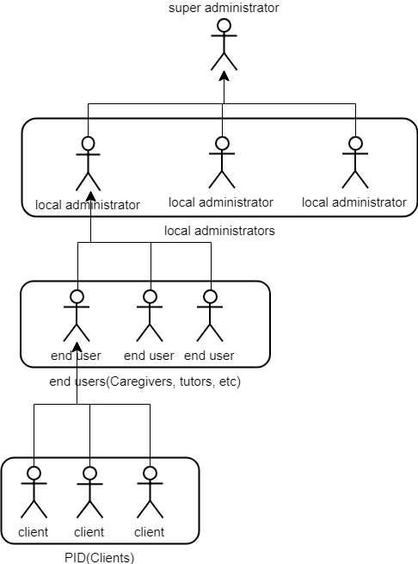

Fig. 1: User categories hierarchy

To ensure the independence of the way to connect the applications to the database, the Representational State Transfer (REST) architectural style commonly used for web services was chosen for the system implementation. The REST architecture has simple interface without additional interlayers, and it does not depend on who makes the request to the system.

The system includes of the following components:

* API interface for communication with applications,
* Web interface for configuring mobile applications,
* external applications that connect with the application via API.

The system architecture is shown in Figure 2.

.

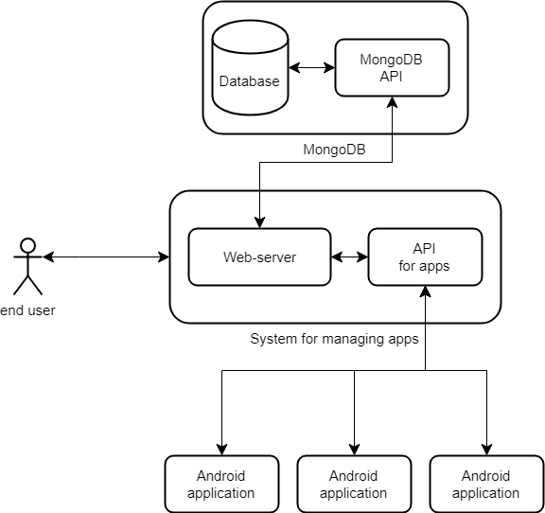

Fig. 2: System architecture